Supporting Information:
Table S1
The total phosphorus (TP, g kg^{–1}), dissolved P (TDP, mg kg^{–1}), and truly soluble P (TSP, mg kg^{–1}) of different-sized soil aggregates in the total 15 soils.
 | Size of aggregates | S1 | S2 | S3 | S4 | S5 | S6 | S7 | S8 | S9 | S10 | S11 | S12 | S13 | S14 | S15
TP | 2–8 mm | 1.48ab | 0.27a | 0.52b | 0.86b | 1.00b | 0.26a | 0.93a | 0.59c | 1.24b | 0.64b | 0.54a | 0.29a | 1.00ab | 0.88b | 0.8c
TP | 0.26–2 mm | 1.58a | 0.20b | 0.66a | 0.93a | 1.48a | 0.27a | 0.87b | 0.89a | 2.45a | 0.7a | 0.57a | 0.28a | 1.24a | 0.98a | 1.16b
TP | 0.053–0.26 mm | 1.32b | 0.16c | 0.38c | 0.59c | 0.97b | 0.29a | 0.76c | 0.78b | 1.25b | 0.63b | 0.60a | 0.28a | 0.98b | 1.03a | 1.87a
TP | <0.053 mm | 0.94c | 0.18c | 0.53b | 0.43d | 0.67c | 0.21c | 0.77c | 0.7b | 0.95c | 0.58c | 0.31b | 0.31a | 0.59c | 0.79c | 0.57d
TDP | 2–8 mm | 24.87a | 1.85b | 4.45d | 18.05a | 4.41c | 4.60a | 9.93c | 18.3b | 38.57a | 3.89b | 3.91c | 3.09c | 13.71b | 16.36a | 25.46a
TDP | 0.26–2 mm | 22.10a | 2.34a | 15.65a | 17.92a | 9.39a | 3.76b | 14.49a | 24.57a | 33.91ab | 3.93b | 5.54b | 4.78a | 14.45b | 18.67a | 17.74b
TDP | 0.053–0.26 mm | 12.62b | 2.29a | 9.33b | 12.57b | 7.64b | 2.83c | 11.21b | 19.42b | 29.30b | 5.49a | 2.29d | 3.76b | 18.64a | 15.63a | 14.45c
TDP | <0.053 mm | 2.21c | 1.42c | 6.52c | 6.25c | 7.37b | 4.05ab | 6.38d | 8.24c | 18.57c | 3.29c | 9.40a | 5.38a | 9.81c | 12.76b | 22.54a
TSP | 2–8 mm | 0.83b | 0.60b | 2.41c | 6.69a | 2.14c | 0.59c | 2.51b | 7.3c | 8.71b | 2.41bc | 2.13b | 2.10b | 3.71c | 2.11a | 4.10c
TSP | 0.26–2 mm | 1.56a | 0.79a | 8.43a | 6.59a | 3.15b | 0.56c | 2.38b | 7.46bc | 10.29a | 2.67b | 2.19b | 1.91b | 8.31a | 1.97ab | 5.24b
TSP | 0.053–0.26 mm | 0.75c | 0.51c | 7.23b | 3.49b | 3.16b | 0.69b | 2.84a | 8.21a | 6.62c | 3.01a | 2.71a | 2.65a | 4.14b | 1.83b | 4.28c
TSP | <0.053 mm | 0.53d | 0.56c | 1.25d | 0.70c | 4.77a | 1.46a | 2.79a | 7.68b | 6.26c | 2.22c | 1.80c | 0.88c | 2.12d | 2.54a | 7.31a
Letters in different sized aggregates indicated significant difference at P<0.05 level.
Table S2
Correlation analysis of colloidal P in TP in soil aggregates and soil aggregate associated MWD, GMD, pH, TC, TN, C/N, C/P, Al, Fe, and Ca (n=45). MWD=mean weight diameter, MWD=mean weight diameter, TC=total C, TN=total N.
Indexes |  | Ratio of colloidal P to TP
Indexes |  | 2–8 mm | 0.26–2 mm | 0.053–0.26 mm | <0.053 mm | MWD | GMD | pH | TC | TN | TP | C/N | C/P | Al | Fe | Ca
Ratio of colloidal P  to TP | 2–8 mm | 1
Ratio of colloidal P  to TP | 0.26–2 mm | 0.577** | 1
Ratio of colloidal P  to TP | 0.053–0.26 mm | 0.614** | 0.662** | 1
Ratio of colloidal P  to TP | <0.053 mm | 0.152 | -0.115 | -0.246 | 1
MWD  GMD  pH  TC  TN  TP |  | 0.241 | -0.035 | -0.055 | 0.584** | 1
 |  | 0.001 | -0.236 | -0.224 | 0.401* | 0.461 | 1
 |  | 0.207 | -0.033 | -0.133 | 0.710** | 0.314 | 0.411 | 1
 |  | -0.245 | -0.378* | 0.291 | 0.236 | 0.452* | 0.002 | 0.419 | 1
 |  | -0.282 | -0.371* | -0.378* | 0.063 | 0.317 | -0.123 | 0.160 | 0.921* | 1
 |  | 0.359 | -0.018 | -0.054 | 0.092 | 0.196 | -0.135 | -0.076 | 0.162 | 0.330* | 1
C/N |  | -0.337 | -0.340 | -0.219 | -0.047 | -0.298* | 0.540** | 0.729** | 0.586* | 0.243 | -0.108 | 1
C/P |  | 0.247 | -0.270 | -0.020 | -0.346 | 0.295 | 0.148 | 0.240 | 0.478** | 0.385** | -0.503** | 0.438** | 1
Al |  | -0.186 | 0.130 | 0.065 | -0.536** | -0.038 | 0.077 | -0.309* | -0.280* | -0.307* | 0.100 | -0.072 | -0.327* | 1
Fe |  | -0.318 | -0.345 | 0.147 | -0.310 | -0.235 | -0.112 | -0.222 | 0.014 | 0.098 | 0.379** | -0.189 | -0.302* | 0.498* | 1
Ca |  | 0.318 | -0.042 | -0.162 | 0.532** | 0.152 | 0.162 | 0.429** | 0.443** | 0.413** | 0.154 | 0.222 | 0.166 | -0.446** | -0.222 | 1
* Significant correlation at the 0.05 level (two-tailed). ** Significant correlation at the 0.01 level (two-tailed)

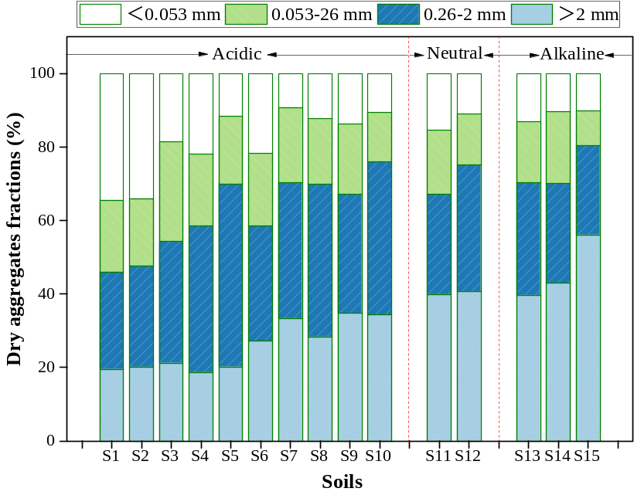
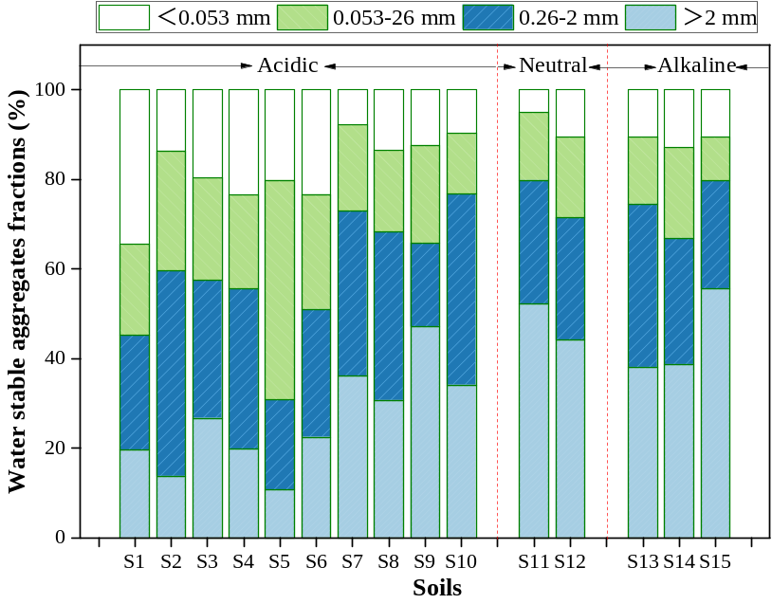
Figure S1 Water-stable aggregate (WSA) and Dry soil aggregates (DSA) fractions of soils.

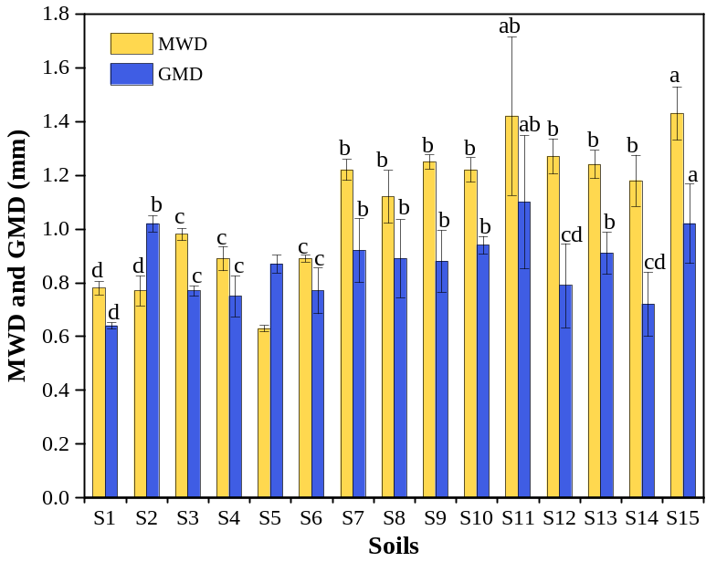
Figure S2 Mean weight diameter (MWD) and geometric mean diameter (WMD) of different soil aggregates. Letters indicated significant difference among soils at P < 0.05 level.

